MUSIC THERAPY INTAKE FORM (ADULT)

CONTACT DETAILS
- Name of person filling out this form:
- Relationship to client:
- Name of other significant caregiver/s of client:
- Client’s full name:
- Client’s age and date of birth:
- Client’s address:
- NDIS number:
- Phone number:
- Email address:
- Email for Music therapy invoices to be sent to:

MY MEDICAL INFORMATION
- Are you on any medications that I should be aware of? Y or N
If yes please list the medications:

- Do you have any allergies or sensitivities that I should be aware of? Y or N (eg - air freshener, carpet etc)

- Are there any precautions I should be aware of in working with you? Y or N (eg - seizures, biting, self-injurious behaviour, etc)

- Do you have respiratory issues?

- Please specify your medical diagnosis:

- If relevant, please list your GP and phone number:

- If relevant, please list both recent and current allied health supports:

- I do / do not give (please circle) permission for Lisa Dowling (RMT) to contact the above clinician/s.
- If relevant, please list your previous experience with music therapy, including the name of the Registered Music Therapist:
REASONS FOR REFERRAL TO MUSIC THERAPY
- I understand Music Therapy is an allied health profession in which music-based activities and engagement can be utilised to support me for non-musical outcomes. I am hoping music therapy to provide me with:

Please discuss your strengths:

Please discuss your abilities:

MY NDIS GOALS
Please list your NDIS goals here or attach a copy of your NDIS plan with this document.

MY MOTOR INFORMATION

- Are you fully ambulatory? Y or N
- Do you have any fine or gross motor difficulties? Y or N
- Do you have full use of your limbs? Y or N

MY SENSORY INFORMATION
- Do you have any sensory issues? Y or N
- Do you have any differences in hearing or other senses? Y on N
- Are you overstimulated by sounds, lights or crowds? Y or N
- Do you engage in repetitive behaviours? Y or N
- Do you have any sensitivities to or extreme preferences for particular sounds? Y or N
- Do you resist physical support? Y or N
MY COMMUNCATION INFORMATION
- Do you have any speech or language differences? Y or N
- Can you communicate verbally? Y or N
If no, please indicate mode of communication

- Do others understand you? Y or N
- Do you have idiosyncratic speech? (speech that is individual to you)? Y or N
- Do you understand or react to what is being said to you? Y or N
- Do you have difficulty in understanding speech? Y or N
- Have you been diagnosed with any hearing difficulties? Y or N
- Do you have difficulty hearing sounds? Y or N

MY COGNITIVE INFORMATION

- Do you have any learning difficulties i.e. learning disorder/dyslexia/inattention/difficulty remembering tasks) Y or N

Please provide any extra significant information

MY EMOTIONAL AND SOCIAL INFORMATION
- Do you have any emotional or social difficulties? Y or N
- Do you get upset or angry easily? Y or N
- Have you suffered emotional trauma or recent changes in life circumstances? Y or N
- Do you have difficulty relating to family or peers? Y or N
- Do you participate in conversation with others? Y on N
- Are there any home or community activities that you particularly enjoy? Y or N?

Please provide any extra significant information
MY MUSICAL INFORMATION:

- Please describe your musical experiences.

- Do you have an aptitude for music (instrumental/ singing/ dance)?

- Please list your favourite music artist/s: (Please be comprehensive)

1.
2.

3.

- Please list your favourite songs: (Please be comprehensive)
1.
2.

3.

4.

- Please list particular songs that you dislike:

- Please list musical instruments that you particularly like or respond well to:

- Please list musical instruments that you do not particularly like or respond well to:

OTHER SIGNIFICANT INFORMATION
- Is there anything the previous questions have not covered that you feel is important for me to know?

Absences and Cancellations:
At least forty-eight (48) hours advance notice is required for all cancellations or rescheduling needs. The full fee will be charged for sessions missed without such notification.

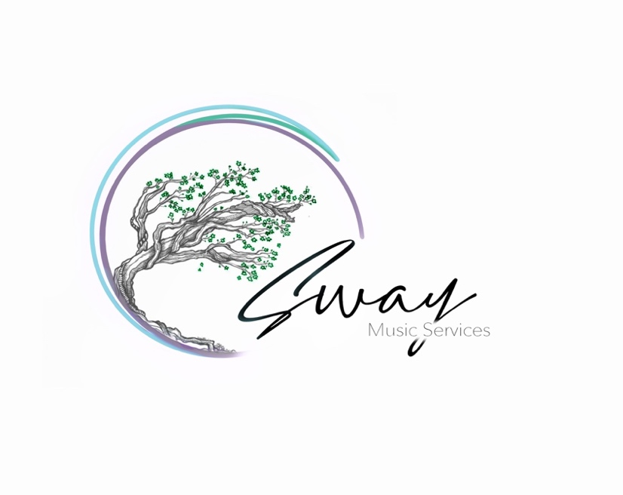
LISA DOWLING · MMusTH, MMus, BArts
Registered Music Therapist
Neurologic Music Therapist

Shop 28A C-Square
52-64 Currie Street, Nambour QLD 4560

M: 0439 647 566
E: lisa@swaymusicservices.com
www.swaymusicservices.com

ABN: 653 774 073 11

